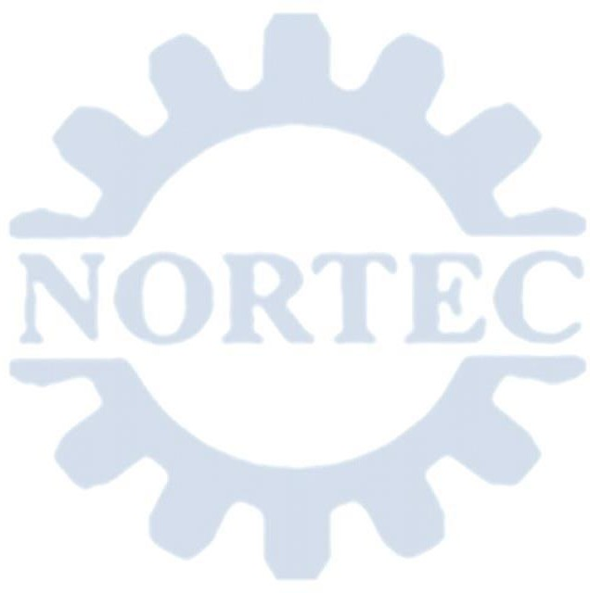
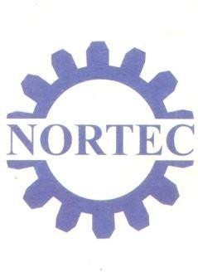

MINISTRY OF TECHNOLOGY AND SCIENCE

REPUBLIC OF ZAMBIA

NORTHERN TECHNICAL COLLEGE MANAGEMENT BOARD

Chela Road | Telephone | :+260-212-680423  :+260-212-680142
P.O.BOX 250093 | Email | : principal@nortec.edu.zm
Ndola | Website | :www.nortec.edu.zm
Zambia
Our Reference……………………..… Your Reference………………………
19 January, 2026

The Human Resource Manager,
Dear Sir/ Madam,

RE: REQUEST FOR INTERNSHIP FOR MUSUMALI MUSANYA NRC NO. 391104/82/1
The above named student has completed a LEVEL 4 CERTIFICATE IN HEAVY EQUIPMENT ENGINEERING (935). The student is therefore requested to go for Internship, and as part of the Curriculum Internship is a mandatory requirement. We therefore, as Northern Technical College Management, request you to provide internship for the named student at your organization to facilitate for his progression.
The following are the subjects which the student has learned:

YEAR-1 | YEAR-2
Workshop Processes | Hydraulics Pneumatics And Braking System
Engineering Mathematics I | Steering Suspension And Undercarriage
Engineering Science | Entrepreneurship
Engineering Drawing l | Workshop Practice ll
Communication Skills | Heavy Equipment Electrical
Introduction To Computers
Diesel Engines And Transmission System
Workshop Practice l

This internship will start when the named student is considered. Kindly consider for this to support our student's skill. Your support will be highly appreciated.
Yours sincerely,
NRTHERN TECHNICAL COLLEGE

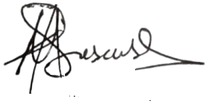
MARTIN KASONSO PRINCIPAL
All Correspondence to be addressed to the Principal

